Cashdata release 2008.1.0 Patch 1 is to be applied only to Cashdata 2008 Release (for all licence types including Cashdata 2008 D.I.Y. Superannuation edition). This patch modifies superannuation reports. Policy note 1 in notes to accounts has been corrected to refer to Australian Accounting Interpretations. A year correction has been made to superannuation fund minutes in resect of the appointment of auditors.
FILES TO DOWNLOAD
There is only one file to download.
DOWNLOAD INSTRUCTIONS
- Print this page for reference.
- Left mouse click on the 'download' icon to the left of this screen
- Select “Save this file to Disk “ (or similar) and then select an appropriate directory to store the software eg C:\Downloads
INSTALLATION INSTRUCTIONS
- All Cashdata sessions on your standalone PC, Workgroup and or Network should be closed (exited).
- If the patch is to be installed onto a Network - it is only necessary to install the patch on the computer that has the license file e.g. the server or primary workstation. This can be located by menu items File | Cashdata Setup | Startup.
- Using Windows Explorer locate the file “Cashdata2008.1patch1.exe” in your downloads folder eg. “C:\Downloads” (or other folder created in “Download Instructions” Download step 3 above) and with your mouse, double click on this self extracting file.
- Winzip self extractor will launch and display in the “Unzip to folder” “C:\Program Files\Cashdata\M_Detail”. This is the default location of Cashdata reports for a stand alone system. If this is correct proceed with the extraction.
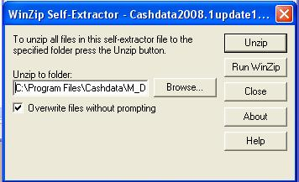
- If the folder location requires changing e.g. because of a non-standard installation folder or it is to update a server installation it will be necessary to key the correct path in the “unzip to folder” section of the extractor. To locate the path launch Cashdata and follow the menu. File | Cashdata Setup | Startup. In the server example below the license path is shown as P:\Cashdata.
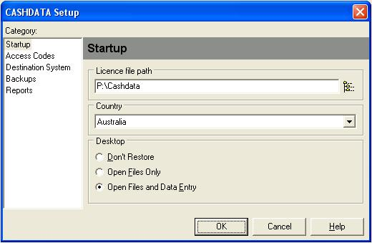

- Either key the path e.g. “P:\Cashdata\M_Detail” for the above example or use the browse button in the Winzip extractor to locate the license file path then the M_Detail subfolder. The correct path will appear without the need to key, by using the browse button. After the correct path appears in the “Unzip to Folder” section of the extractor, proceed with the extraction. Olds files will be overwritten.
INSTALLATION CHECK
- Launch Cashdata with a 2007 year superannuation fund as the active file on the desktop. Run any 2007 notes to accounts reports. Reports| Superannuation | Final reports | Notes.
- The report should make reference in Note 1 to “Australian Accounting Interpretations or other authoritative pronouncements”.
- If the notes report contains these words the patch has been successful

